INDIGENOUS AUSTRALIAN CULTURE DAY
CLOTHES: ON ABORIGINAL DAY YOU CAN WEAR
ABORIGINAL FLAG COLOURD CLOTHES. IF YOU DO NOT WEAR ABORIGINAL FLAG COLOURED CLOTHS YOU HAVE TO BRING An ABORIGINAL FLAG.
DATE: THE DATE OF THE EVENT IS 5\07\2017
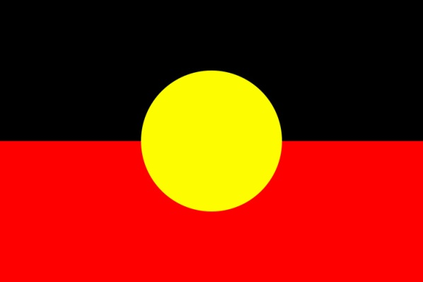Why we are doing it: We are doing it because we respect the aboriginals because the white people took over the land which was originally the aboriginals land.
Activities: we will be doing basket weaving, model shelters and dot painting.

